


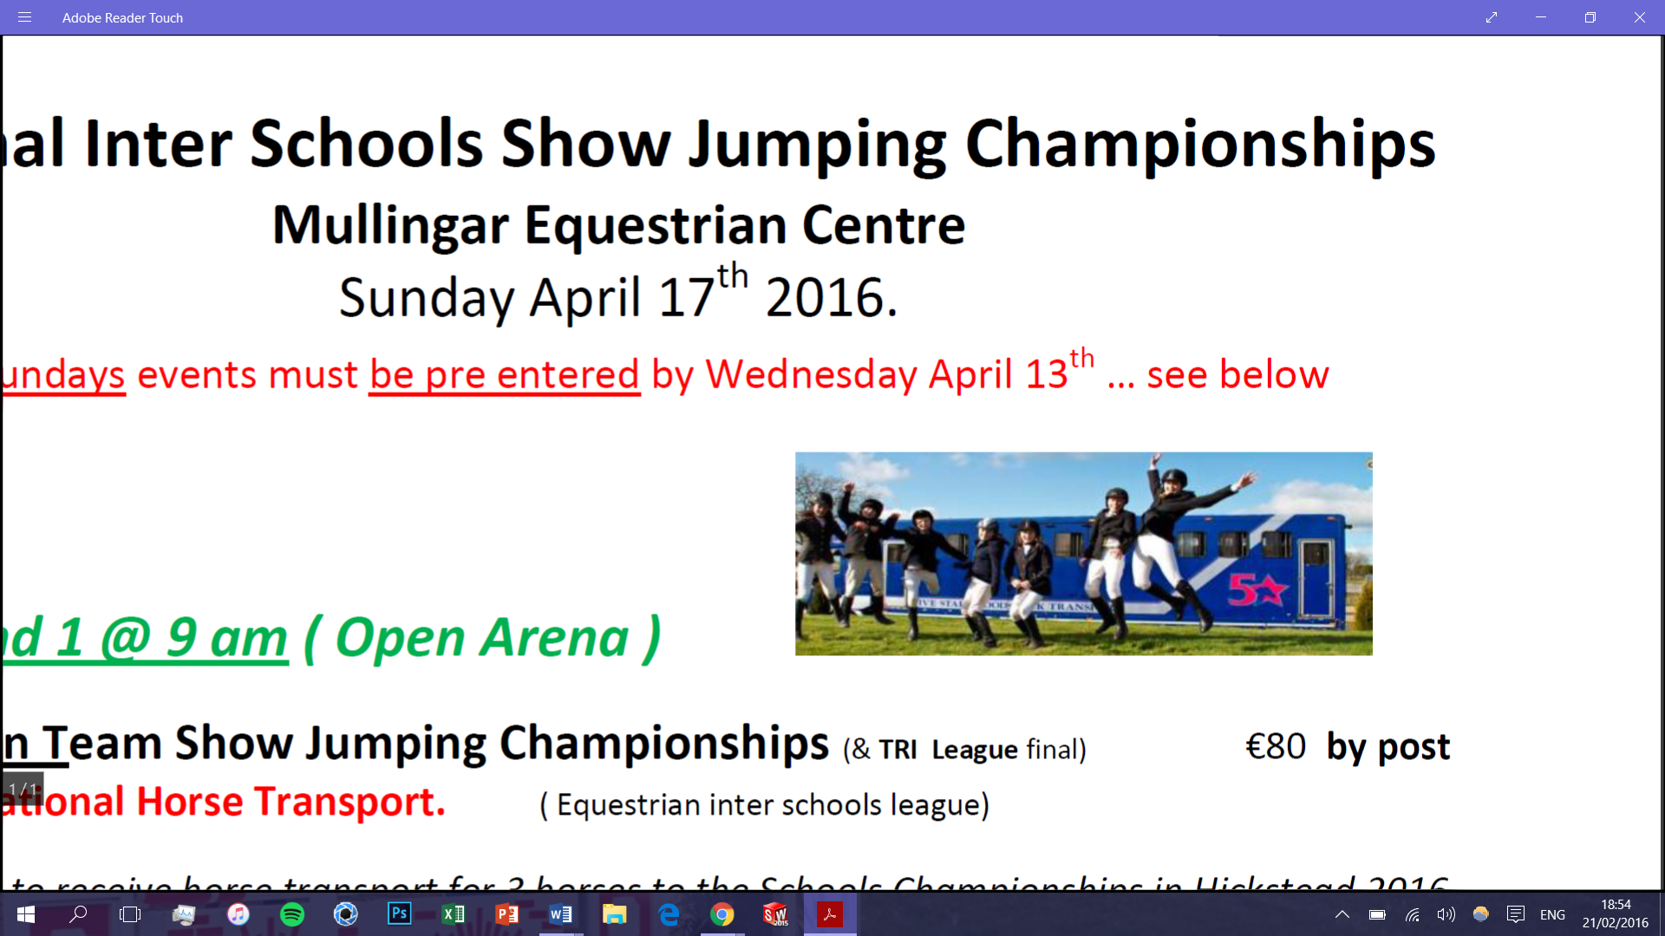
WELCOMES to the National Inter Schools Show Jumping Championships April 8th 2017
Novice Team Championships Draw
 | 1 Oakland Navy Team Edenderry
 | RIDER | Horse | R1 | R2 | TT
1 | Aisling Holt | Freddy
2 | Ceili Holt | Snowy
3 | Parick Carey | Prince
4 | Nioami Lynch | Tyson
 | 2 Newbridge College Silver
 | HORSE/PONY | RIDER | R1 | R2 | TT
1 | Camira Pride | Ella Kelly
2 | Othello | Orla Ring
3 | Little field Clover | Lucy ross
4 | Mullabaloo | Niamh Behan
 | 3 Maynooth Education Campus
 | HORSE/PONY | RIDER | R1 | R2 | TT
1 | Bambi | Emma Keogh
2 |  | Katie Deane
3 | Zola | Eve Connolly
4 | Roscrea Chester | Billy Coonan
 | 4 Athlone community college
 | HORSE/PONY | RIDER | R1 | R2 | TT
1 | Echl Brave | Caoimhe Guthrie
2 | Moydrum Mollie | Giollasisa Jamil
3 | Moydrum roger | Anna Malone
4 | Coliie | Rachel Webb
 | 5 Calasantius College
5 | RIDER | Horse | R1 | R2 | TT
1 | Jane Field | Belle
2 | Keeva Crudden | Dreamer
3 | Emma O Callaghan | Tigger
4
 | 6 Oakland Red Team
 | HORSE/PONY | Rider | R1 | R2 | TT
1 | Texas | Lauren Kane
2 | Beny | Maeve Mc Intyre
3 | Penure Princess | Hannah Smullen
4 | Biscuit | James Hickey
 | 7 Ballymahon Vocational
 | HORSE /PONY | RIDER | R1 | R2 | TT
1 | Newman | Grace Esler
2 | Elliots Point | Emer Esler
3 | Shanes lad | Daragh Whyte
4 | Abel Star | Edel Whyte
 | 8 Assumpta Grammer School
 | HORSE /PONY | RIDER | R1 | R2 | TT
1 | Knockash Willis | Lucy Savage
2 | Lismahon Houdini | Ella kinkaid
3 | Flap Jack | Zara Burns
4 | Calyco Jack Emily Stewart
 | 9 Ballymena Academy Navy Team
 | HORSE/PONY | RIDER | R1 | R2 | TT
1 | Forest Lodge Rambler | Alex Byrne
2 | Danny | Zoe Dickey
3 | Minnie Manice Justice | Myah Mc Clean
4 | Pippa | Alex Henry Mc Cool
 | 10 Newbridge College Gold
 | HORSE/PONY | RIDER | R1 | R2 | TT
1 | Rosemarie Rebel | Ivanna Dempsey
2 | Miss Gort | Lola Gabor Sweeney
3 | Dingle June | Kate Maloney
4 | The Alders Bobby Dazzler | Laura Kavanagh
 | 11 Presentation Athenry
 | HORSE/PONY | RIDER | R1 | R2 | TT
1 | Slieve Rusheen Oscar | Ava Donoghoe
2 | Cree Mystic | Alicia Donoghue
3 | Nicky Rising | Ava Finn
4 | Lurgan King | Phelim Mc Cann
 | 12 Hunter House College
 | HORSE/PONY | RIDER | R1 | R2 | TT
1 | Suzie | Lucy Toombs
2 | Millparks Slievnagarragh | Sophia Bloomfield Faiers
3 | Shannon | Sophie Lister Tinsley
4 | Simply Abigail | Gillian Grogan
 | 13 Ballymena Academy Red Team
 | HORSE/PONY | RIDER | R1 | R2 | TT
1 | Magic Rhythm | Taylor Hunter
2 | Chief | Jo Henry Mc Cool
3 | Charlie B | Alex Henry Mc Cool
4 | Chinook Calibra | Alex Byrne
 | 14 St Brendans Birr
 | HORSE/PONY | RIDER | R1 | R2 | TT
1 | Rachel Cosgrove | Magic
2 | Lee Loonan | Odie
3 | Dara Purcell | Rocco
4 | Hannah Landy | Tory
 | Sponsors | TRI
 |  | 5 * Horse Transport
 |  | Mullingar Equestrian
 |  | Equestrian Interschools
MAX 3 teams in the warm up arena at any 1 time
Judges : Genieve Collins, Margaret Fagan
Coursebuilder : Michael Keavney

