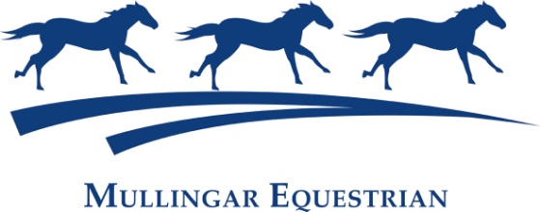
SJI Horse & Pony Summer League 2023
& Rising Stars Young Horse Series qualifiers/Sportsman unreg
Saturday June 24th
Saturday July 1st,18th 15th, 22nd & 29th
Entries on SJI LIVE by 4pm the previous day

International Sand : Horses @9am
1 80 cm
2 90 cm
3 95cm -4YO Rising Stars Young horse qualifier
4 Metre
5 1.05 -5YO Rising Stars Young horse qualifier
6 1.10
7 1.15 -6/7YO Rising Stars horse qualifier
8 1.20
9 1.30
10 1.35
Sand 1 Ponies from 1pm
Newcomer 40cm/60cm
Glencarraig 60cm U9 128/138 Ponies
Glencarraig 70cm U11 128/138 Ponies
11 128 70cm
12 128 80cm
13 128 90cm
14 128 Metre
15 138/148 80cm
16 138/148 90cm
17 138 Metre
18 148 Metre
19 138 1.10 20 148 1.10 21 149 1.20 22 148 1.25 Entry Fee €24 /Prizes in Final
Sand 1 :Sportsman UN-REG Jumping : x-poles to 90cm (H & P) from 9.30 X -POLES /50cm €15 /60cm to 90cm : Entry Fee €20 Entries on www.mullingarequestrian.com /before 4pm Fridays /Late entries on the day 25
Enquiries: Dorothy 087-2488017 , Enya 085-7759065 Course Designers : Robert Fagan, Abdeslam Chitnalah Safety Officer: Pat Mc Cormack For all updates/changes check our FACEBOOK page or www.mullingarequestrian.com T&C : Withdrawals must be done through SJI LIVE (In My Declarations) before the close of entries €10 admin fee will be retained on each withdrawn entry (€5 for league shows.) Any entry queries must be submitted by email to info@mullingarequestrian.com within 14 days of show . or for league shows contact us before the start of the class

